CALL FOR SUBMISSIONS:
Community engagement for inclusive rural transformation and gender equality
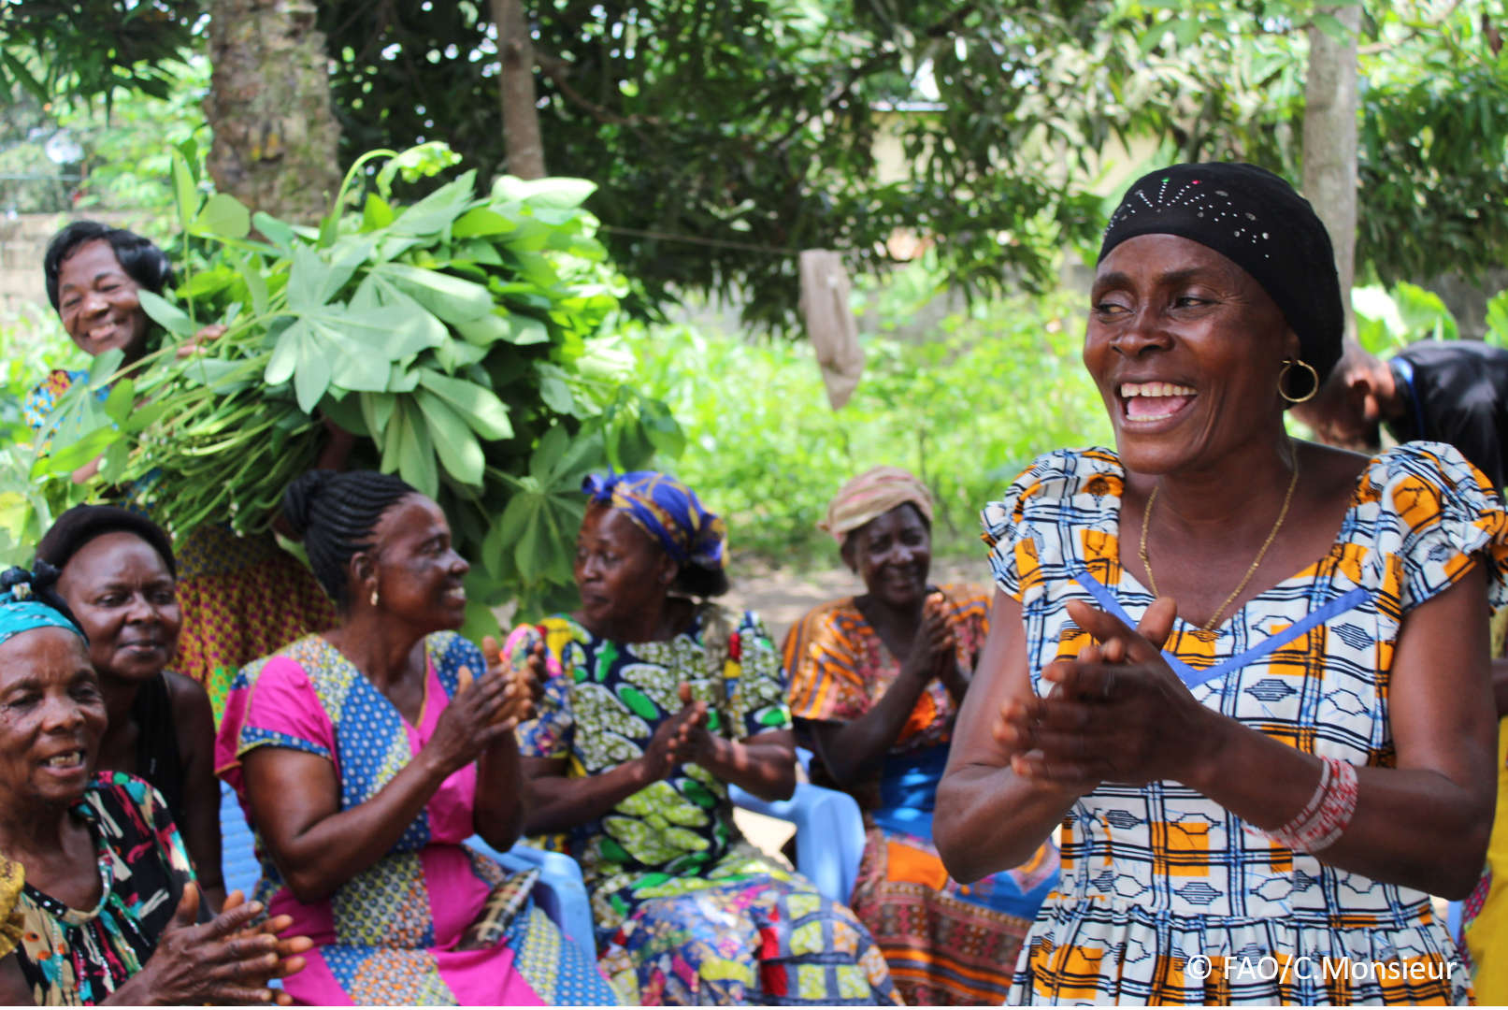
The objective of this call for submissions is to collect good practices, experiences, and lessons learnt on the use of community engagement for inclusive rural transformation and gender equality. The initiative, organized by the Rural Transformation and Gender Equality Division (ESP), seeks to gather insights from a diverse range of contributors, both within FAO and from external stakeholders. Its goal is to share knowledge, foster learning, and guide the scaling up of community engagement and community-led collective action to leave no one behind. The call builds on FAO's past efforts in this area, such as the Community Engagement Days series of webinars.
The call for submissions is open until 27 November 2024.

How to take part in this call for submissions:
To take part in this Call for submissions, please register to the FSN Forum, if you are not yet a member, or “sign in” to your account. Please review the topic note to understand the criteria we are considering for this call. If you wish to learn more about community engagement, you may refer to the background document. Once you have completed this submission template, upload it in the box “Post your contribution” on the call webpage, or, alternatively, send it to fsn-moderator@fao.org.
Please keep the length of submissions limited to 1,500 words and feel also free to attach relevant supporting materials.

Template for submissions

Contact person | Name: Idris Gata  Organization/Unit: SmallGrowr Limited  Country: Nigeria  Email address: idrisa@smallgrowr.com
Name/title of the good practice | Catalyzing Community-based Seedling Production Enterprises in Nigeria (CCSPREN).
Where is the good practice taking place? (Multiple selection allowed) | ☐ Europe and Central Asia  ☐ Latin America and the Caribbean  ☐ North Africa and Near East  ☒ Sub-Saharan Africa  ☐ Asia and the Pacific  ☐ North America  ☐ Global
Affiliation | ☐ Farmer and producer organizations  ☐ Trade Union  ☐ Informal community-based, farmer-based or self-help group  ☐ Research and academia  ☐ Government  ☐ Local/traditional authorities  ☒ Private Sector  ☐ Civil Society Organization  ☐ Intergovernmental Organization (e.g. UN system, World Bank)  ☒ Resource Partner/Donor  ☐ Other (please specify)
In which sector(s) and context (s) have you used this community engagement good practice? (Multiple selections allowed) | ☐ Education  ☐ Health and Sanitation  ☒ Food production in agrifood systems (please also tick the sub-categories)  ☒ Crop cultivation  ☐ Fisheries and aquaculture production  ☐ Livestock  ☐ Forestry  ☐ Agroforestry  ☒ Horticulture  ☐ Apiculture (beekeeping)  ☐ Agroecology and sustainable farming practices  ☒ Soil and water management  ☐ Other: ____________  ☒ Post-production in agrifood systems (please also tick the sub-categories)  ☐ Processing and value addition  ☒ Marketing and retailing  ☐ Transporting  ☐ Food loss and waste  ☐ Packaging  ☐ Storage  ☐ Distribution  ☐ Other _________  ☒ Gender Equality  ☒ Climate Action  ☐ Citizenship and Governance  ☐ Social Protection  ☐ Humanitarian and protracted crisis  ☐ Conflict resolution, peace and resilience  ☐ Digital innovation  ☐ Other sector (please specify) _________
Who are the financial partners supporting this good practice, if applicable? | NIL
- In a few sentences, summarize your community engagement good practice.
Through CCSPREN, SmallGrowr limited is increasing access to productive resources and markets for female vegetable farmers, while incentivising the adoption of regenerative practices. To achieve this, SmallGrowr Ltd. Adopted a market-based facilitation approach where women were trained in seedling production across 30 communities, these women were evaluated, enabling the top 40% to receive input grants as leg-up support to start seedling production. The remaining 60% were retrained in regenerative farming and commissioned as community-based agents/merchants. These agents mobilize & facilitate knowledge transfers to farmers, market seedlings/inputs for local producers; and facilitate linkages to off-takers before harvest dates. The female seedling producers are able to manage the risks and offer seedlings as well as other input credits to female farmers in their networks.
- What problem(s) or challenge(s) does your good practice aim to address through community engagement?
SmallGrowr Limited’s approach aims to sustainably tackle the following:
- Low productivity of vegetable farmers.
- Economic marginalization and lack of safety nets for women, youth and persons with disability.
- Vulnerability of rural households to inclement weather conditions as a result of climate change.
- Describe your good practice in more detail. Include the main guiding principles, the desired changes or outcomes you aim to achieve (Theory of Change), and the key phases of implementation.
The overarching goal of SmallGrowr Ltd.’s CCSPREN approach is to increase the productivity and livelihood outcomes for vegetable producing households within the intervention geographies.
The project is guided by the principle of inclusive market systems development – offering catalytic grants/leg-up support to the most vulnerable; while offering non-financial incentives, technical support and facilitating investments on a risk & cost-sharing basis.
The project seeks to
- facilitate trade by project-assisted women-owned enterprises.
- Increase the number of hectares under sustainable management practices;
- Reduce post-harvest losses by 20%.
This is being achieved through three main pathways which include capacity-building, rural enterprise development and regenerative/sustainable production.
Key phases of implementation include:
- Community Engagements/sensitization
- Mobilization of women for free training in seedling production.
- Seedling production on a cost-share basis using local structures – including buy-backs.
- Commissioning of community-based agents.
- Upscaling of project-assisted seedling producers (clustering, business registrations, access to finance, technical support on marketing and tech adoption)
- Who are the key actors and stakeholders involved in the design and implementation of the good practice, and what are their respective roles? Consider local partners, government, local authorities, community radios, civil society, research, the private sector, etc.
- Research Partners (Institute for Agricultural Research, Zaria; Global Forum for Sustainable Rural Development; AGRA-NAERLS)
- Government (National Agricultural Seeds Council)
- Local Communities (community heads and influential farmers)
- Private Sector (PremiumOne).
- How does your intervention ensure inclusivity and equal and meaningful participation within the community?
CCSPREN integrated a Gender Equality, Disability and Social Inclusion (GEDSI) Strategy from the outset to ensure that women, youth and persons with disabilities (PWDs) are specifically targeted by the intervention. All activities are benchmarked with a target of 50% women and 50% youth, while enterprise development support is reserved strictly for women – these enterprises are given the Gender Makes Business Sense plus (GmBS+) training to drive gender transformation after the project. Similarly, PWDs are targeted with home gardening skills, value-addition and marketing skills in addition to leg-up support. The M&E team created gender disaggregated indicators for each activity and population (New jobs created, PWDs supported etc)
- By using community engagement, what results and impacts have your good practice achieved?
1. Trained thirty-six (36) women and PWDs in seedling production.
2. ⁠Facilitated the establishment of sixteen (16) new women-owned seedling production enterprises, provided input grants and piloted buy-back of seedlings.
3. ⁠Local enterprises insulated with additional support towards business diversification and household strengthening (backyard gardening and cottage processing). These gardens which were established with nutritious leafy vegetables like Jute mallow and Spinach, already generate about 17,000 Naira for beneficiaries while contributing to household nutrition.
4. ⁠Leveraging our incentive model, local agents have trained over 1,100 vegetable farmers in host communities (52% female; 57% youth). They are also leading aggregation of demands from markets to protect fellow farmers from exploitation by middlemen, while standardizing commodity measurements and tracking market prices. As a pilot, a total of 1.125 tons of cabbage and 2.67 tons of tomatoes were harvested and sold across the four sites. The crops harvested were sold at a price 8% higher than the average price offered by middlemen in local markets within the same time period.
- Among these results, has the good practice led to improvements in terms of gender equality, women’s empowerment, and/or social inclusion?
Female farmers are now more likely to participate in trainings and meetings as the engagements are facilitated by both female and male community-based agents/merchants. Rural women in the intervention geographies now rely less on men for aid or access to markets. They are now more likely to directly engage in trade activities leveraging the entry points provided by the project such as clustered seedling production; and incentive-based demand aggregation and retailing.
- What key challenges did you encounter while implementing the community engagement activities, and how did you address them?
As a result of the initial push back from local buying agents in the intervention areas, the female community-based agents could not access local markets to aggregate demands for vegetables. However, the project leveraged its network to link the female community-based agents to high-value markets. A result of this and ability to demand for input credits, local farmers reach out to these female agents on their own to do business.
- What are the key lesson learned from your community engagement good practice?
Rural enterprises are an underutilized vehicle that can be used to drive inclusive agricultural investments and sustainability within emerging markets.
- Has this practice been replicated in the same context or in different contexts?
This practice was deployed in the horticultural value chain. However, SmallGrowr Ltd. Will be replicating it in the grain and raw cashew nut value chains. The primary building blocks for this practice/approach are viable rural businesses and structured community-based agents.
- How sustainable are the results achieved by this good practice?
To facilitate sustainability from the outset, this approach is primarily market-based. Policy advocacies are necessary to sustain efforts (for instance, free business registrations and tax holidays for rural women-owned businesses).
- Based on the conversations FAO held during the Community Engagement days, a definition of community engagement for empowerment was proposed:

“Community engagement for empowerment and community-led collective action can be defined as an inclusive and participatory process that enables community members to become active agents of change in decisions affecting their lives, health, and environment. This process develops their capacity to achieve sustainable outcomes for improved rural livelihoods. Embracing a rights-based approach, it prioritizes the agency and participation of all community members, regardless of gender identity, sexual orientation, age, ethnicity, caste, socioeconomic status, political affiliation, migration status, or ability/disability. Indeed, inclusive approaches recognize the complexities of overlapping marginalization and discrimination that can exclude different community members from decision-making processes and implement strategies to foster their participation, agency and empowerment.”

We invite you to contribute to this definition. What would you add or change?

Community engagement for empowerment and community-led collective action can also be a platform for top-to-bottom collaborations. With an enabling environment and the right investments in rural changemakers; local communities – including the marginalized populations therein – are an effective channel for inclusive rural transformation.
- Based on your experience, what gaps or areas for improvement still need to be addressed in the field of community engagement?
To sustain outcomes and increase the agency of marginalized populations, there is a need for additional investments in rural businesses in under-resourced communities – empowering them to lead engagements on a market basis. There is a need to recognize these hidden businesses as a critical component of food systems, and drive inclusive investments through them.
- What do you think is FAO's role in the field of community engagement? How can FAO support and enhance interventions like yours, if applicable?
Often referred to as “missing chains”, rural enterprises are often informal and hidden, but highly effective in driving change with the right incentives. FAO can plug in the gaps through:
- Policy advocacy towards removing barriers to formal registration for these businesses.
- Facilitating corporate partnerships for these rural businesses to strengthen their value proposition to local actors, and enhance their influence.
- Increase equitable funding to upscale rural businesses as a localization and sustainability strategy.
Link(s) to specific references about your good practice (e.g. reports, communication products, videos, articles) | SmallGrowr Limited Project update (October 2024) Linkedinhttps://www.linkedin.com/posts/smallgrowr-limited_  Fact-Sheet (September 2024) CCSPREN Project-Fact Sheet. GDrive Document

The call for submissions is directly aligned with the thematic components of collective action within FAO's Programme Priority Areas (PPAs), specifically Better Life 1 (Gender Equality and Rural Women’s Empowerment), Better Life 2 (Inclusive Rural Transformation) and Better Life 3 (Agriculture and Food Emergencies).

